**Project Proposal**

|  |  |  |  |  |  |  |  |
| --- | --- | --- | --- | --- | --- | --- | --- |
| ADP Program | | | Computer Science | | | | |
| Project ID  *(for office use)* | | |  | | | | |
| Title of Project | | | Tanks! | | | | |
| Type of project | | | [√] Traditional [ ] Industrial [ ] Continuing | | | | |
| Nature of project | | | [√] **D**evelopment [ ] **R**esearch [ ] **S**urvey | | | | |
| Area of specialization/ Field | | | Combat Games | | | | |
| **Project Group Members** | | | | | | | | |
| Sr.# | Reg. # | Student Name | | CGPA | Email ID | Phone # | Signature | |
| (i) | TeamLead AF23LHB3047 | AbdulRehman Zahid | | 3.70 | mrar08523@gmail.com | +92 342 4057037 |  | |
| (ii) | AF23LHB3292 | Afzaal Ahmad | | 3.53 | afzaal78002.pjb@gmail.com | +92 313 1499910 |  | |
| **Declaration:** Project group members have cleared all prerequisites courses For project as per their degree requirements.  **Supervisor Name and Signatures: Principal:**  Sir Usman _________________ | | | | | | | | |

**7 Core Features of "Tanks!"**

1. **Tank Movement and Control**  
   Smooth and responsive tank navigation, allowing players to move forward, backward, and rotate the turret independently for strategic gameplay.
2. **Shooting and Ammo Mechanics**  
   Implementation of firing system where tanks can shoot shells or bullets with realistic physics and limited or unlimited ammunition depending on the level design.
3. **Health System and Damage Handling**  
   Each tank has a health bar that decreases upon taking enemy hits, introducing a survival element to the gameplay.
4. **Multiple Battle Arenas**  
   Three distinct themed arenas (e.g., Jungle, Desert, and Moon) offering unique environments, obstacles, and challenges to enhance replayability.
5. **Start Menu and Level Selection**  
   A user-friendly start menu that includes options like "Start Game," "Select Arena," "Settings," and "Exit," providing a polished entry point into the game.
6. **Scoring and Game Progression System**  
   Players earn points by destroying enemy tanks; progression to the next level depends on performance, adding a layer of competitiveness.
7. **Audio-Visual Enhancements**  
   Incorporation of sound effects (firing, explosions, engine noise) and visual effects (muzzle flash, smoke, destruction animations) to create an immersive experience.

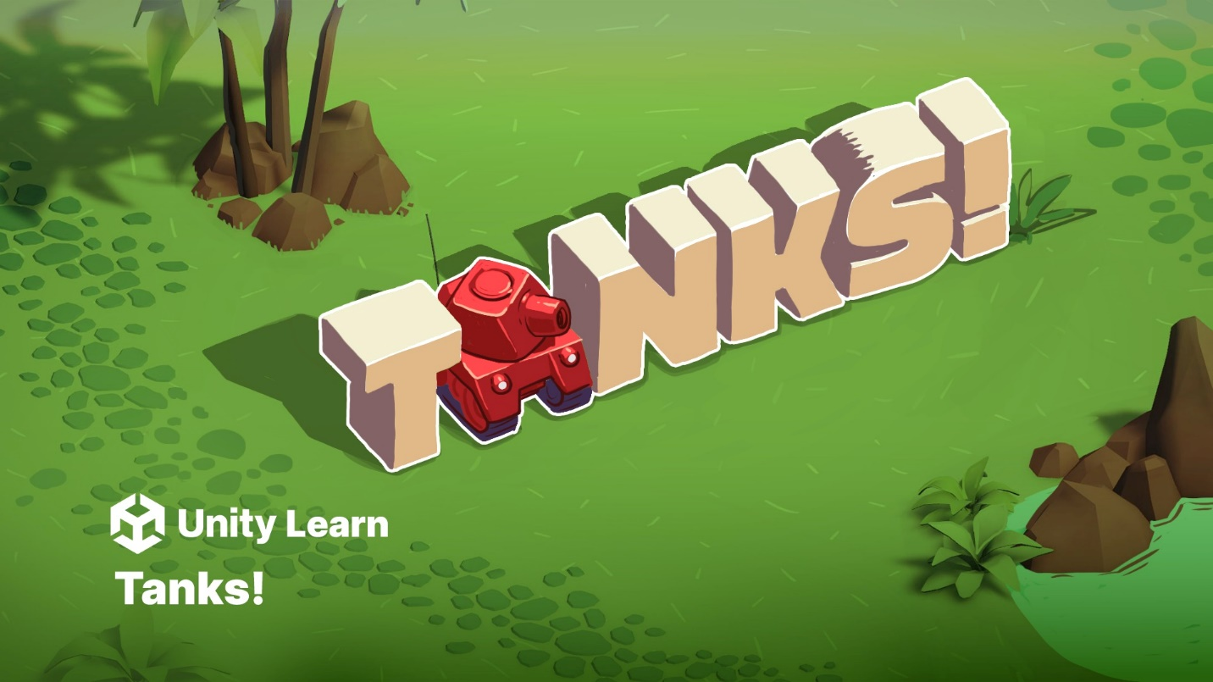

Tank Movement and Control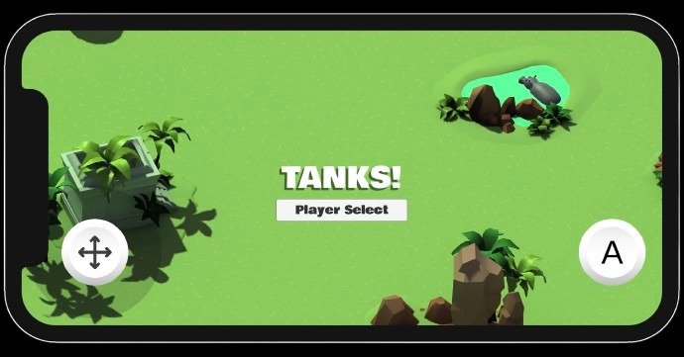

Shooting and Ammo Mechanics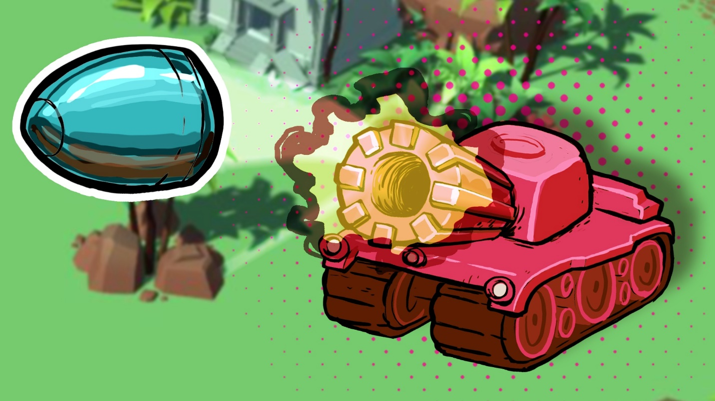

Health System and Damage Handling  
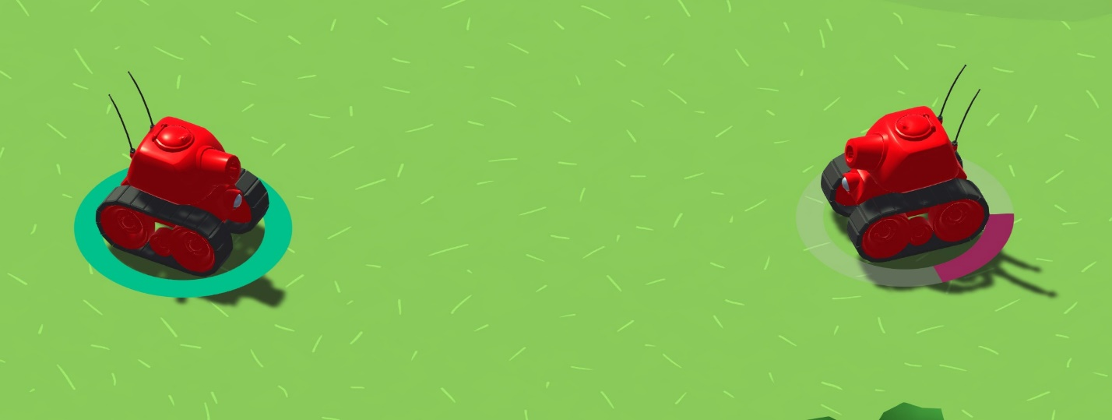Multiple Battle Arenas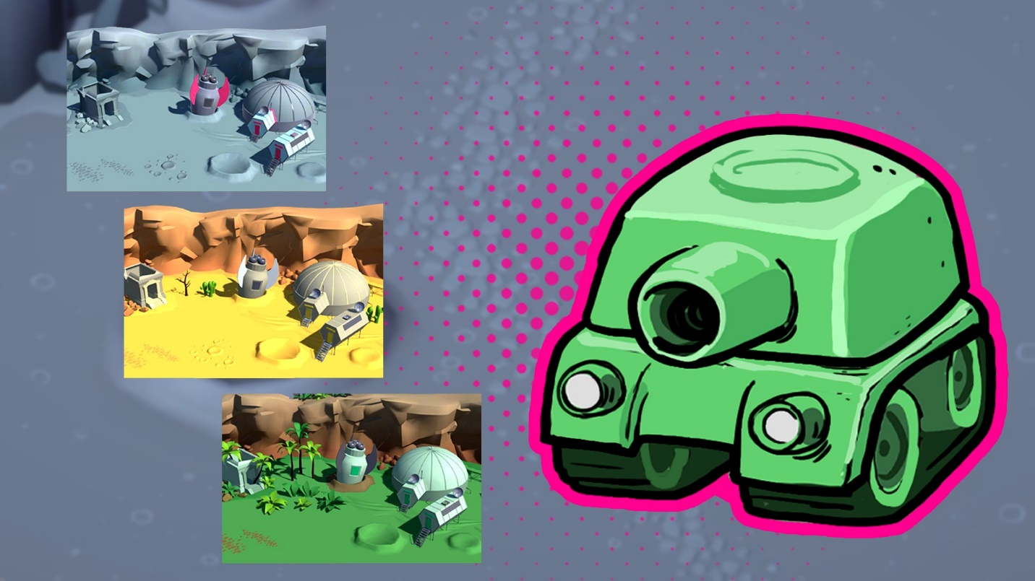Start Menu and Level Selection

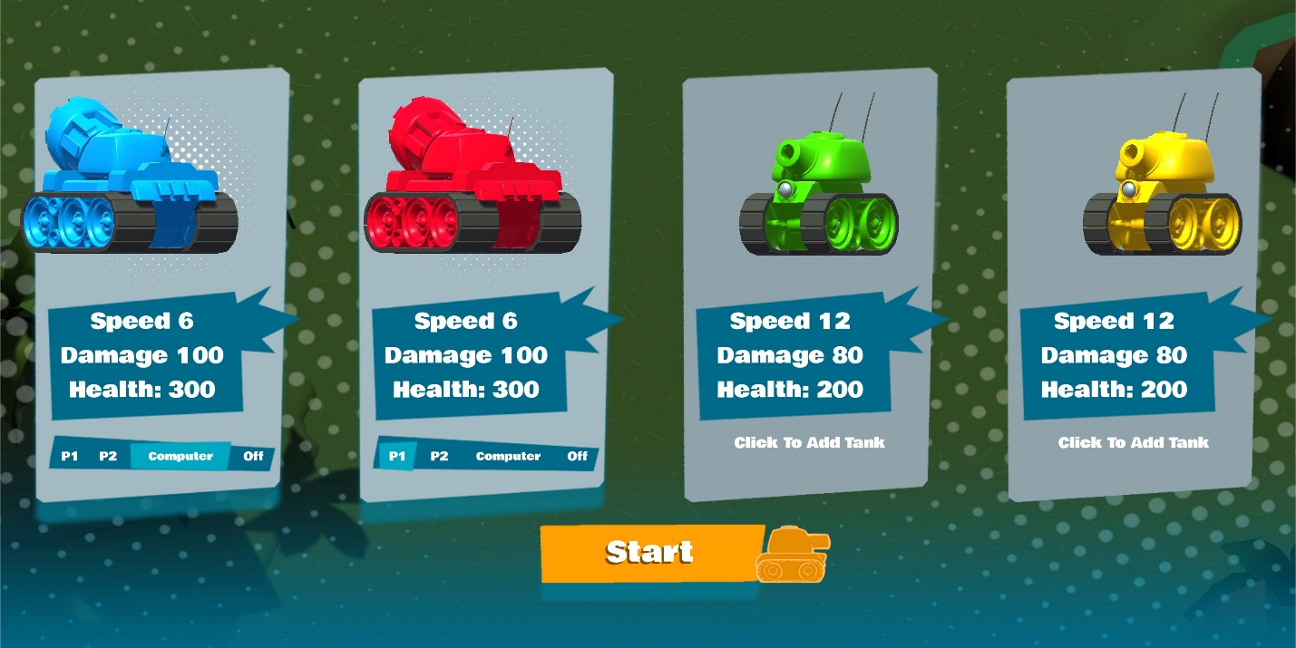  
  
  
  
  
  
  
  
  
  
  
  
  
  
  
  
  
  
  
  
  
  
  
  
  
  
  
  
Scoring and Game Progression System  
  
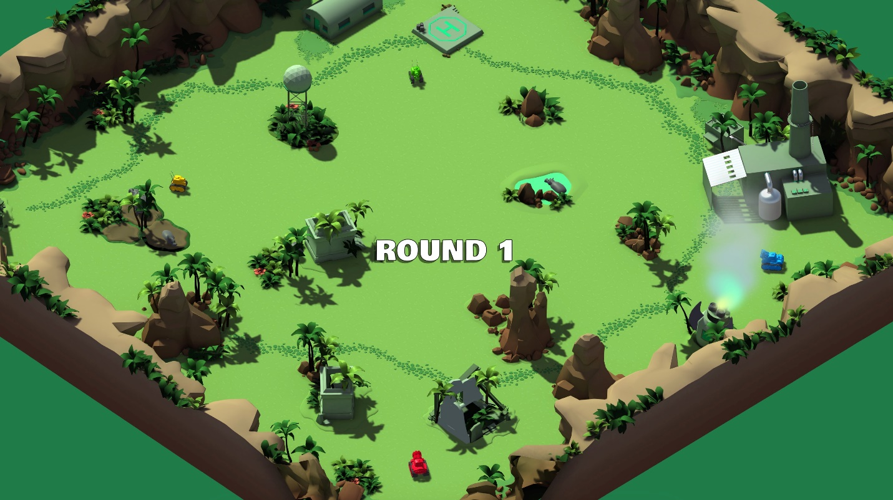  
  
  
  
  
  
  
  
  
  
  
  
  
  
  
  
  
  
  
  
  
  
  
  
  
  
Audio-Visual Enhancements  
  
  
